Ecosystem Services – How Some Wild Animals Protect Human Health

Introduction
An ecosystem is a community of living organisms (plants, animals, and microbes) interacting with each other and their environment.

Ecosystem services are the benefits that humans receive from nature. One example is pollination. Wild bees and other wild animals carry the pollen from the male part of one flower to the female part of another flower. Pollination allows plants to make seeds and fruits around the seeds. Other examples of ecosystem services are described in the figure. | 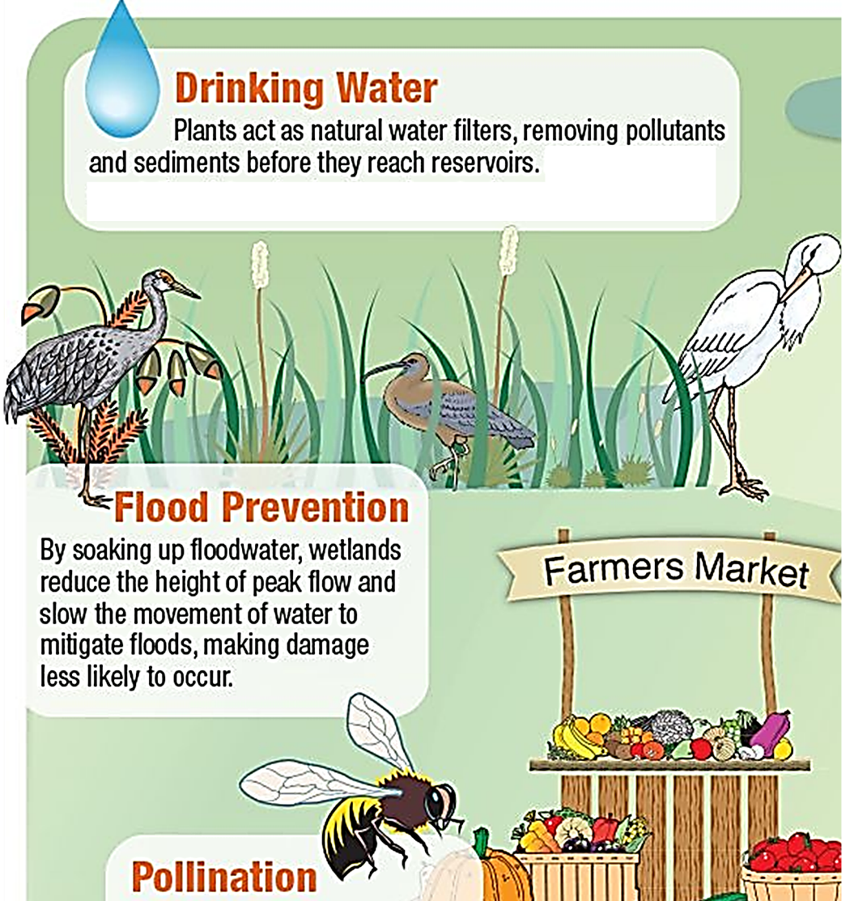

Another ecosystem service is provided by scavengers and decomposers.
- Scavengers (e.g. vultures) eat dead animals and release small molecules.
- Decomposers (e.g. fungi and bacteria) break down organic molecules into smaller molecules.
- These smaller molecules (e.g. CO₂) are nutrients that plants can use to make plant molecules.

1. What would happen if there were no scavengers or decomposers?

In the pages that follow, you will analyze two more examples of ecosystem services.
Example 1 – Vultures

🎥 Watch: “Vultures: the acid-puking, plague-busting heroes of the ecosystem” (https://www.youtube.com/watch?v=1WIUuGCIfcc).  2. Vultures eat dead animals. When a vulture eats the body of an animal that died from an infection, why doesn’t the vulture get sick from that infection? | 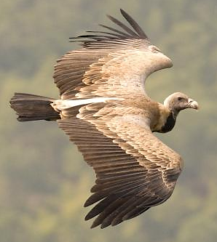

🎥 Watch: “How a die-off of vultures cost a country billions” (https://www.youtube.com/watch?v=OwYPzeD3TJc). (I suggest that you slow down this video to make it easier to understand. You can do this by tapping on the gear that appears when you hover over the bottom of the video; then tap on playback speed and set it to 0.8.)
3. What caused so many vultures in India to die?

4a. When many vultures died, why did the numbers of rats and wild dogs go up? | 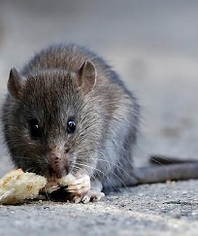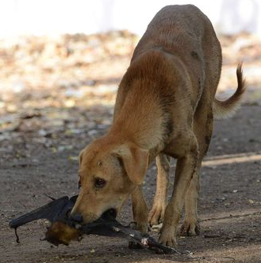

4b. What advantage do vultures have as scavengers, compared to rats and wild dogs?

4c. How did the die-off of vultures cost India billions of dollars?

4d. Suggest a practical approach that could have reduced this problem.

5. Complete this flowchart to show how the decreased number of vultures in India increased human mortality.
Humans used a drug to treat farm animals. This drug was fatal for vultures that ate the dead body of a farm animal that had recently been treated with the drug.

6. Ecosystem services are the helpful things nature does for humans. Fill in the table. Write “none” if the organism does not provide ecosystem services.
Organism | Ecosystem Services Provided by These Organisms
Rabies virus
Vultures

Example 2 – Bats
Most bats hunt at night for flying insects. But how do bats find flying insects at night, when there is little or no light?  Bats use sound to find their prey. A flying bat makes sounds; the bat can locate a flying insect based on the echoes that come back from the flying insect. For example, a bat can tell how far away the insect is by how long it takes for the sound to travel to the insect and the echo to travel back. | 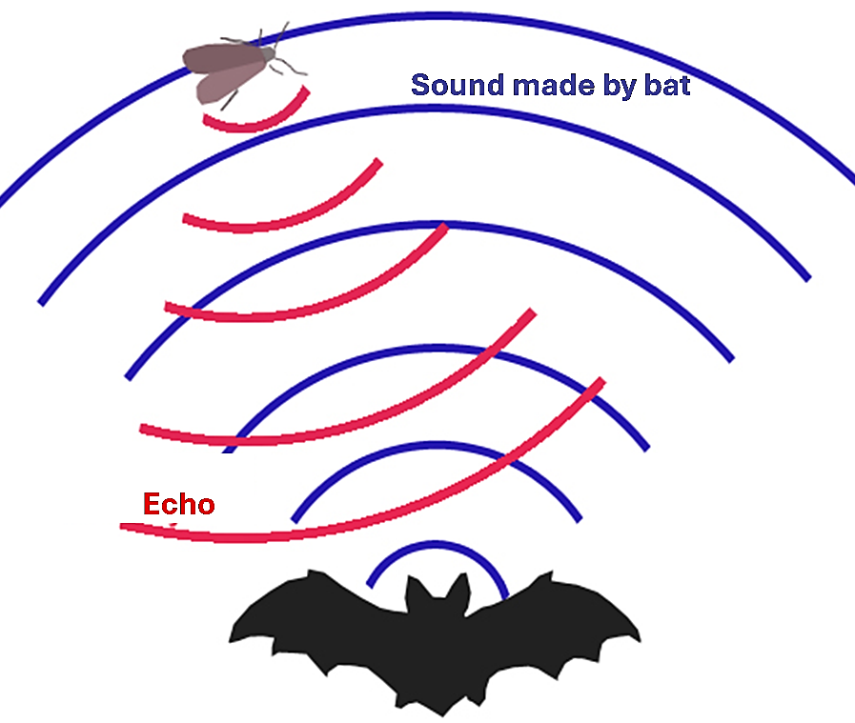

7. Why is the technique that bats use for finding insects called “echolocation”?
A fungus can grow in the skin of hibernating bats. A person accidentally spread this fungus from Europe to North America. During centuries of exposure, European bats adapted to this fungus, so European bats do not get sick when infected. However, North American bats had not adapted, so millions of bats died as this fungus spread across North America.

After this fungus had killed many bats, fewer bats ate fewer insects. The insects that bats eat include crop pests. Farmers responded to the increase in crop pest insects by spraying more insecticides. These poisons spread to humans through wind and water. This caused an increase in infant deaths. | 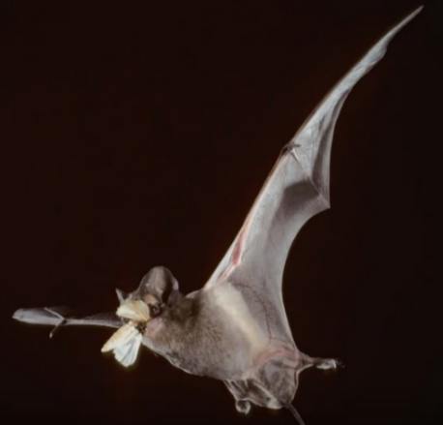

8. Complete this flowchart to show how the spread of this fungus to North America caused an increase in human infant mortality.
A person accidentally spread a fungus from Europe to North America. This fungus killed millions of North American bats.

9a. Define ecosystem services.

9b. What ecosystem service do bats provide?

🎥 Watch: “Stopping White-Nose Syndrome: Can We Save Bats in North America?”
(https://www.youtube.com/watch?v=GNPeHhpBAnE). (This fungus is particularly obvious on the noses of bats as they hang upside down during hibernation. Thus, the disease caused by this fungus is called white-nose syndrome.) If you want to learn more about methods of combating white-nose syndrome, read “Preventing and treating white-nose syndrome” (https://www.fws.gov/story/preventing-and-treating-white-nose-syndrome).

By Dr. Ingrid Waldron, Biology Department, University of Pennsylvania, © 2026. This simpler Student Handout, a more complete version, a PowerPoint with the Student Handout figures, and Teacher Notes (with instructional suggestions and background biology) are available at https://serendipstudio.org/exchange/bioactivities/ecologicaldisturbance.

